**Network Visualization using Gephi**

**Name:** Venkata Sarath Chandra Muktevi

**Date:** 07/18/2019

1. Screenshot of the edge file after adding the 2 rows is:

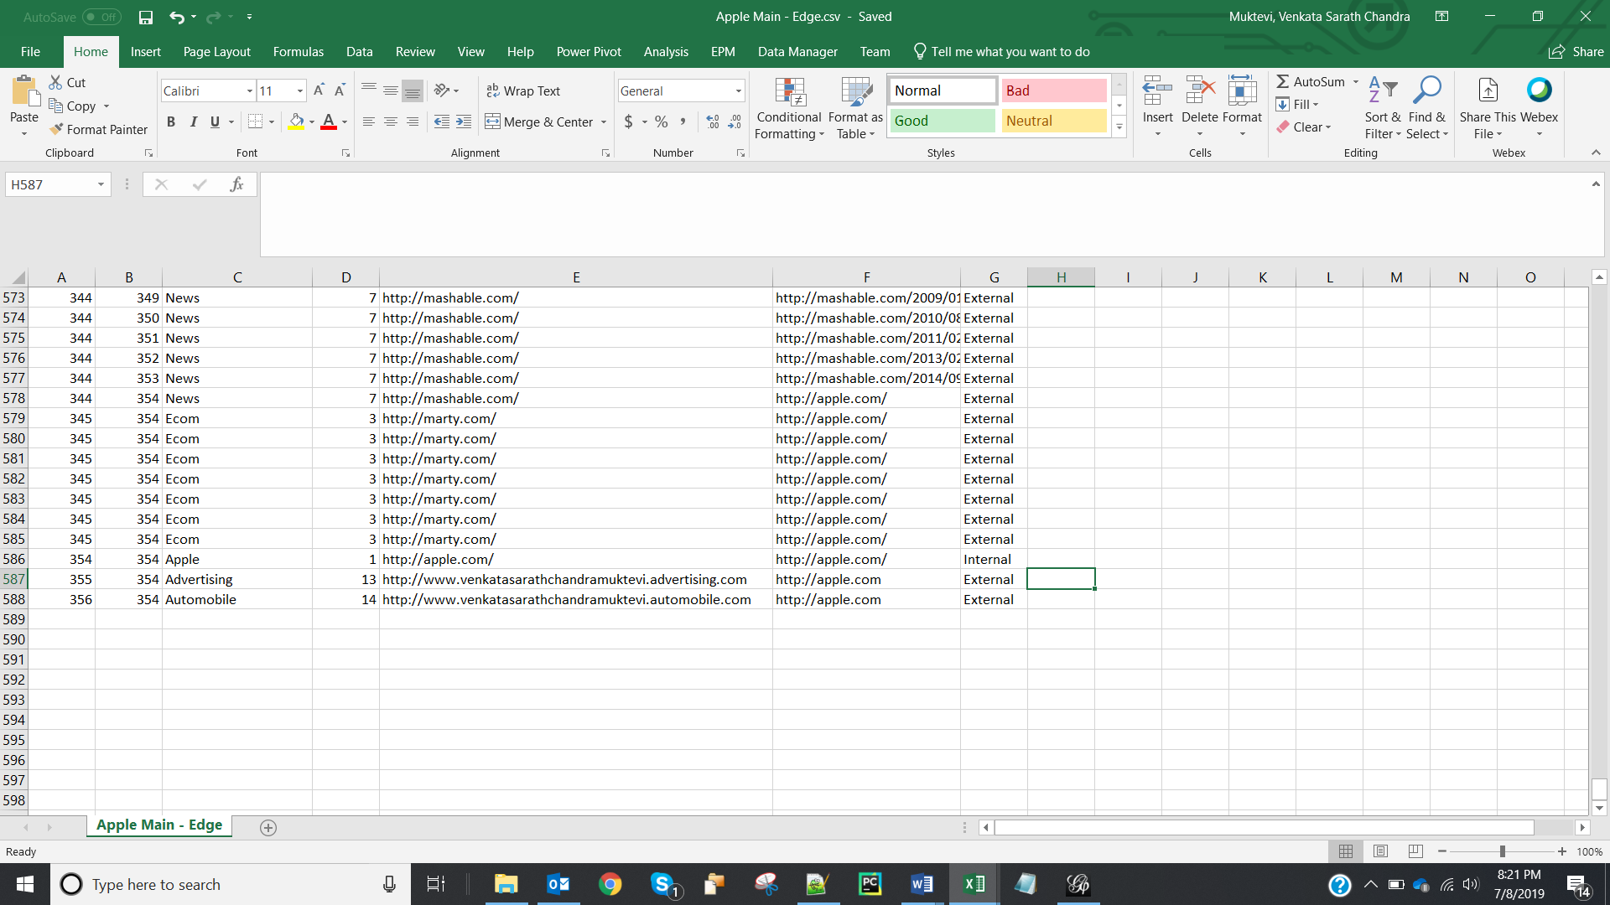

1. Screenshot of the visualization in Overview tab is:

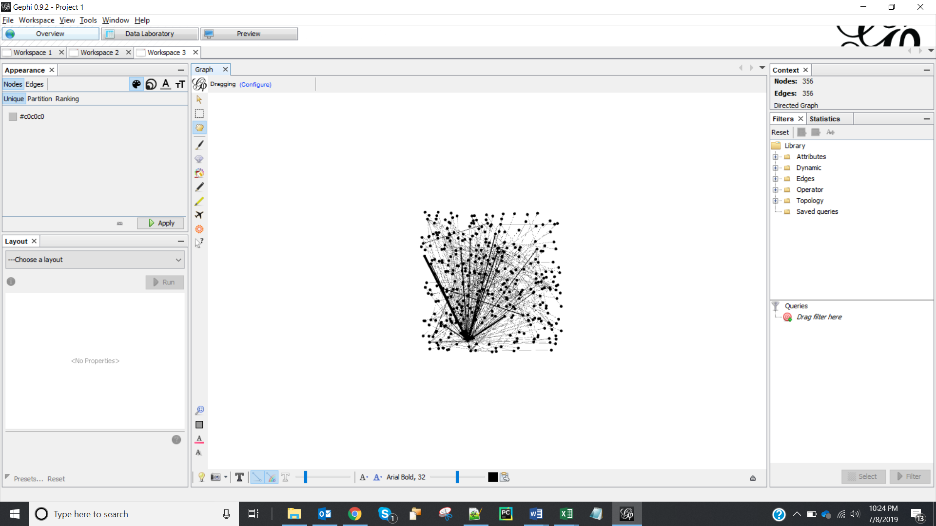

1. Screenshot after setting min and max size is:

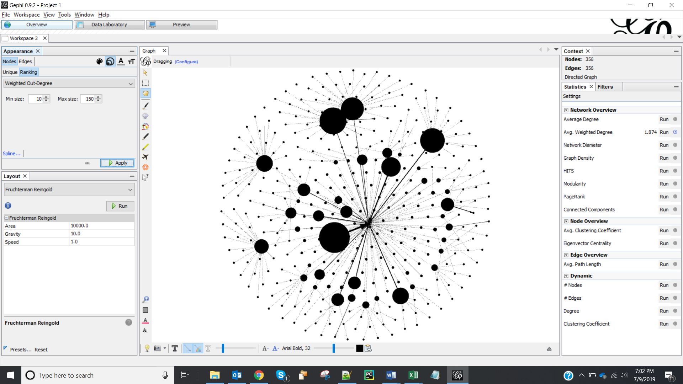

1. The following website got the maximum node size:

[**http://www.venkatasarathchandramuktevi.advertising.com**](http://www.venkatasarathchandramuktevi.advertising.com)

**Industry:** Advertising

1. Screenshot of the visualization after changing the color is:

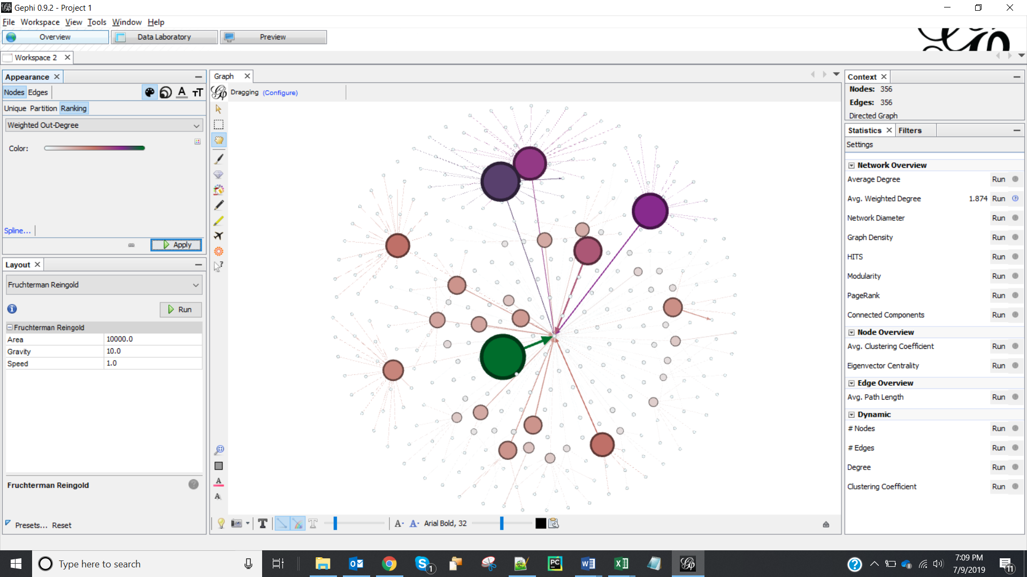

1. Screenshot of the visualization is:

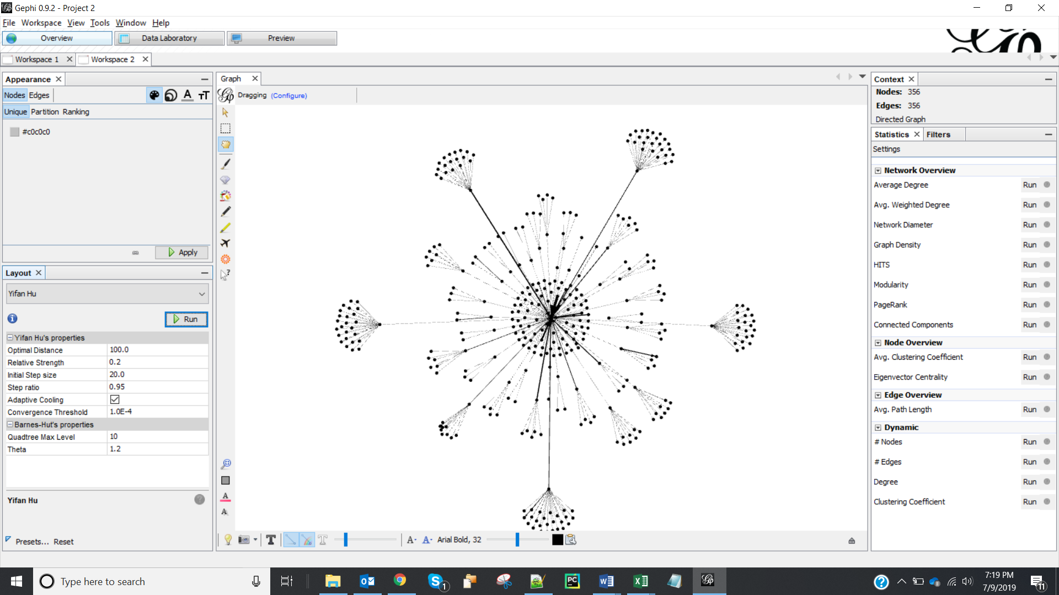

1. Screenshot of the graph after adding colors is:

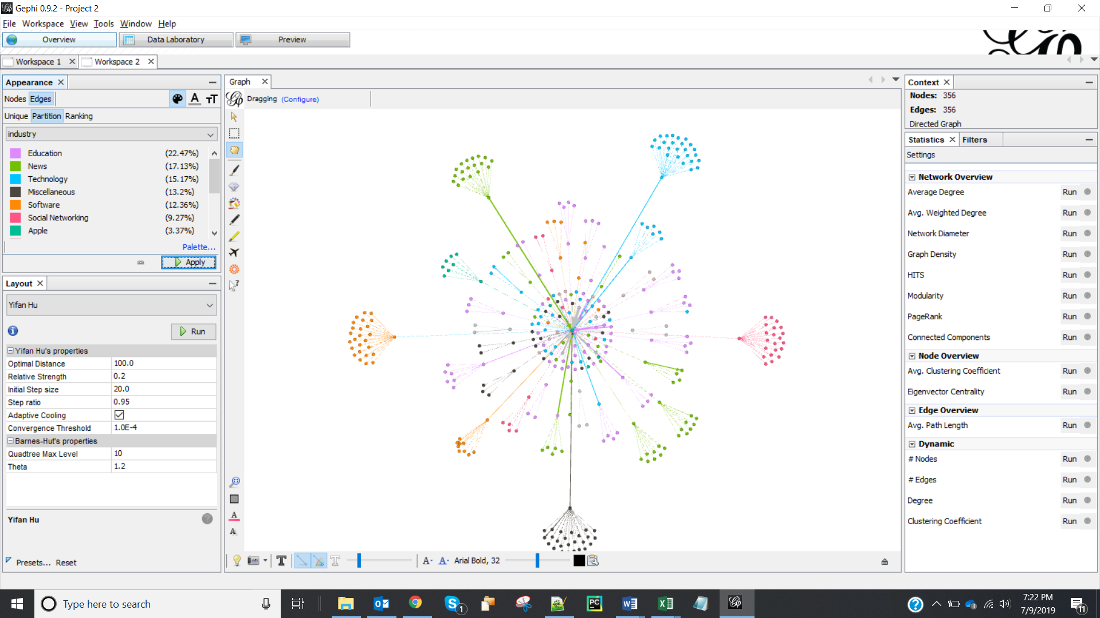

1. The website that have the strongest connection with Apple website is:

Website 1- <http://derstandard.at>

Corresponding Industry - News

Website 2- <http://homestead.com/>

Corresponding Industry – Technology

1. Screenshot of the visualization after assigning colors is:

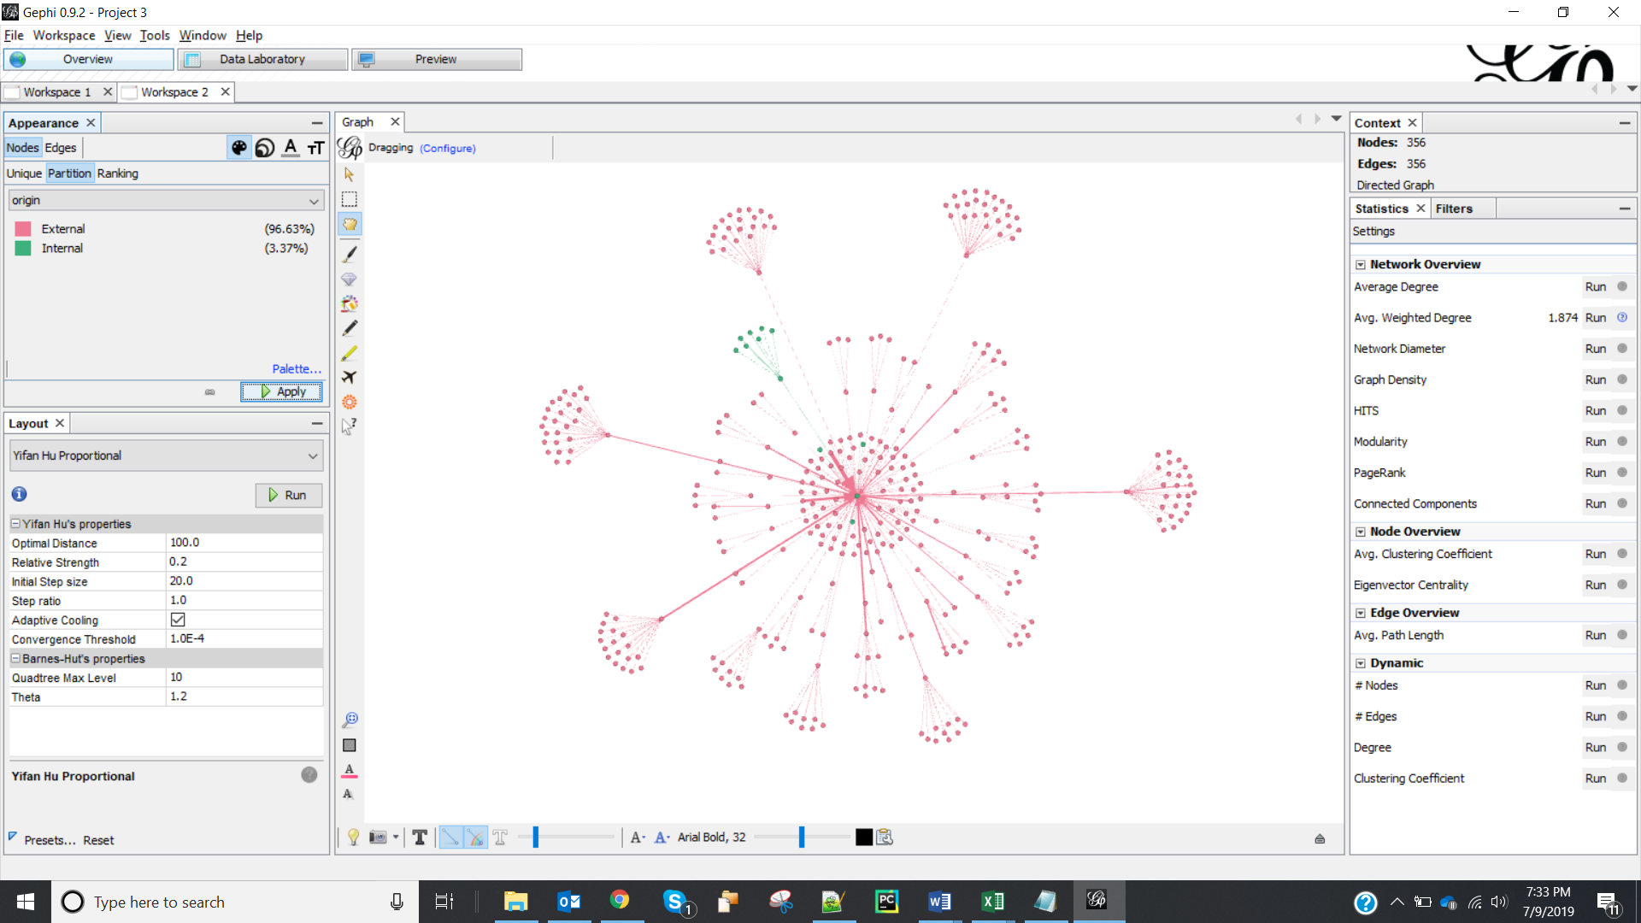

1. **11** internal nodes are visible (excluding the central node)
2. Screenshot for VenkataSarathChandraMuktevi_Website.gexf is:

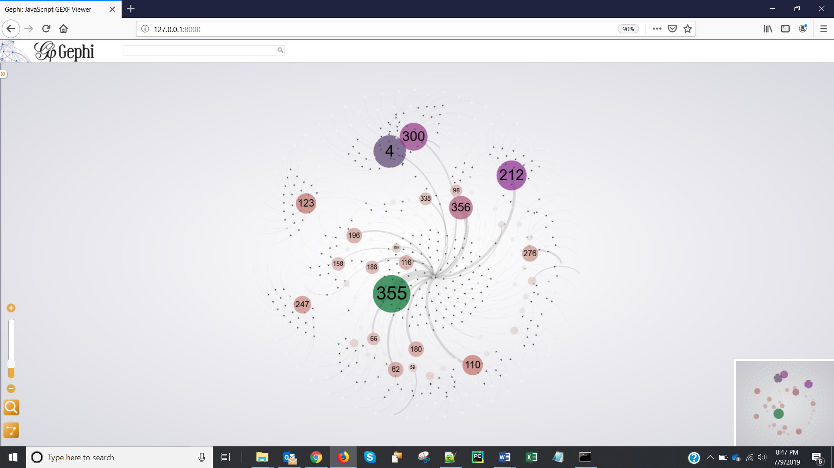

Screenshot for VenkataSarathChandraMuktevi_Industry.gexf is:

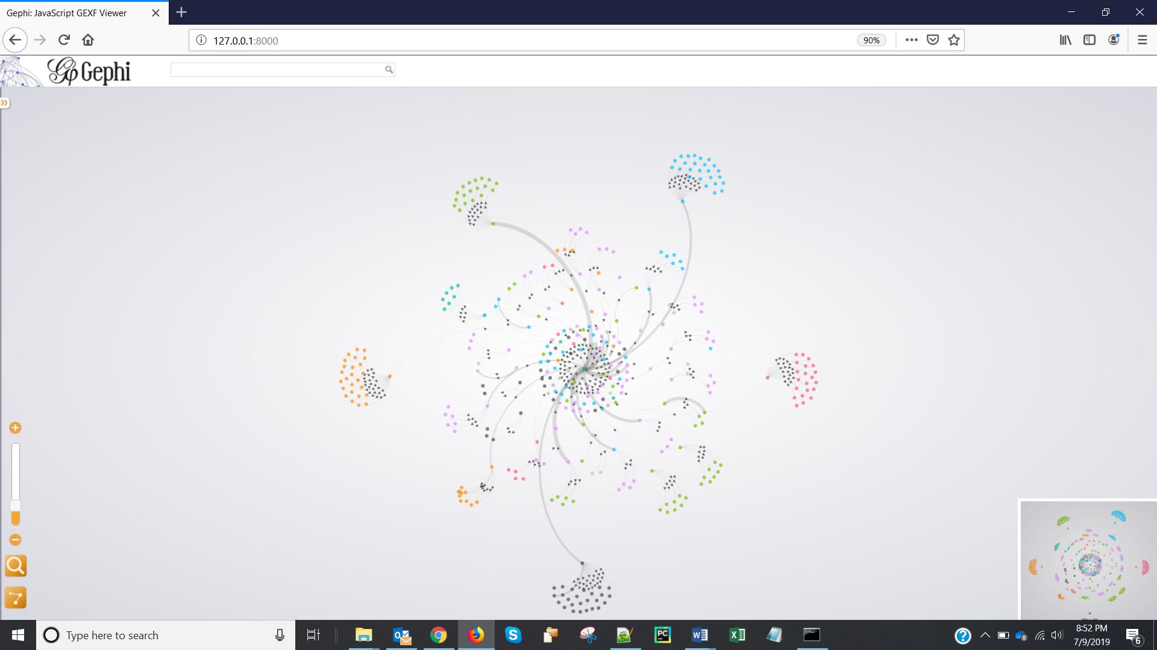

Screenshot for VenkataSarathChandraMuktevi_IntExt.gexf is:

